768 Sq Ft Customizable Small House
$44,900 watertight shell or $109,900 finished (does not include well, septic, foundation or land)
24x32 Single Story, 2 beds, 1 bath
8x12 Bathroom, 12x32 Kitchen/Dining Room/Living Room, 8’ walls
Standard 2x6 construction, R19 Insulation in Walls and R30 in Ceiling
Includes 2 doors and 10 windows, vinyl siding, architectural shingles, shiplap interior walls
Estimated time to build onsite - 5 weeks for watertight shell and additional 5 weeks to finish
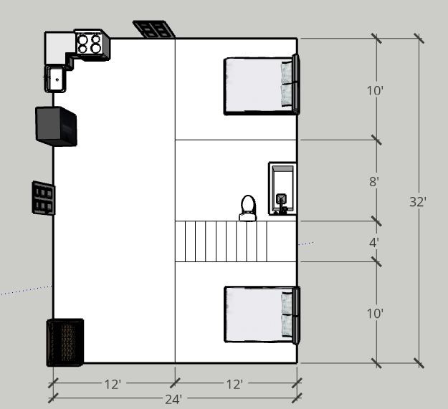
Drawing above is a basic sample layout.
Options:
Metal Roof – Add $4k
Additional Estimated Costs Not Included:
Site clearing/prep - $3k-$12k
Septic - $15k-$25k
Well - $5k-$10k
Land - $50k-$200k
Foundation - $12k-$20k

